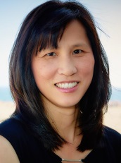 | Chi Quach  2016 – Boston, Massachusetts  Executive Committee 2012-2017
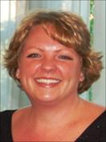 | Stephanie Burnham  2015 – Seattle, Washington  Executive Committee 2011-2016
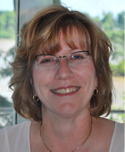 | Mary Burda  2014 – Chicago, Illinois  Executive Committee 2010-2015
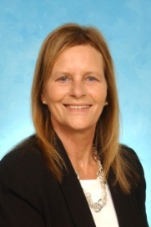 | Linda Shaffer, C-TAGME  2013 – Orlando, Florida  Executive Committee 2008-2014
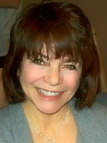 | Donna Guinto, AS, C-TAGME  2012 – San Diego, California  Executive Committee 2008 -2013
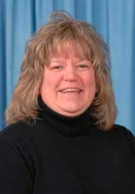 | Sandy K. DelCoglin, BS, C-TAGME  2011 – Boston, Massachusetts  Steering Committee 2008-2012
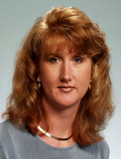 | June Cameron, BA, C-TAGME  2010 – San Antonio, Texas  Steering Committee 2007-2011
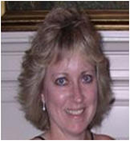 | Kim Agretto, C-TAGME  2009 - Salt Lake City, Utah  Steering Committee 2005-2010
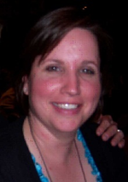 | Gretchen Lynch, C-TAGME  2008 – Toronto, Ontario, Canada  Steering Committee 2004 - 2009
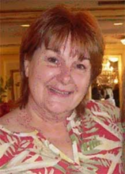 | Ava Fulbright, B.A., C-TAGME  2007 – Washington D.C.  Steering Committee 2003 - 2008
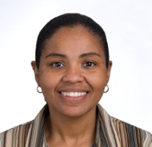 | Sandra Dubard, 2005-2006  2006 - Tucson, AZ  Steering Committee 2002-2006
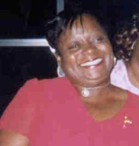 | Juanita L Braxton, MBA 2004-05  2005 – New York, NY  Steering Committee 2001-2005
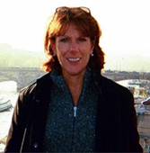 | Donna Turovac 2003-04  2004 - Houston, Texas;  Steering Committee 2001-2005
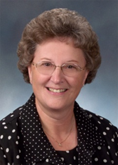 | Ellie Gray 2002-03  2003 - Vancouver, BC, Canada;  Steering Committee 1999-2003
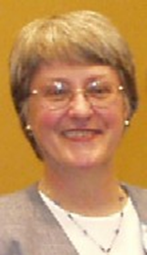 | Ruth Nawotniak, MS 2001-2002  2002 - Baltimore, MD  Steering Committee 1998-2002
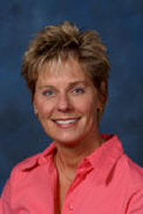 | Machell Thompson, 1998-99  1999 - Orlando, FL;  Steering Committee 1995-1999

