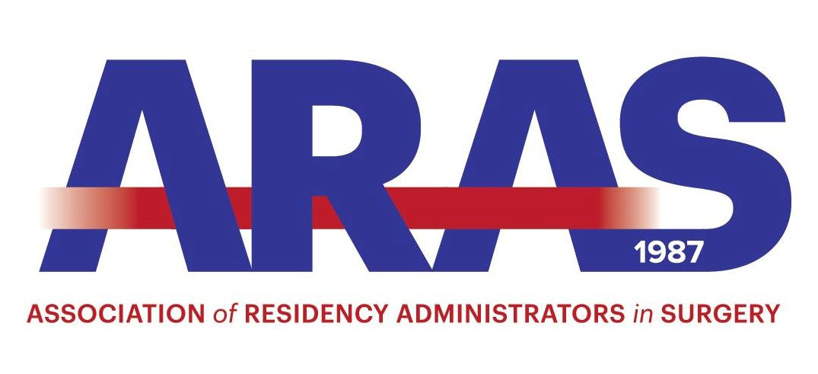
Recognition Award Winners

Name | Year | Institution
Blessing Nnoruka | 2021 | Kaiser Permanente
Valerie Pamatmat | 2020 | UCSF – Fresno
Hemali Shah | 2019 | University of Illinois at Chicago
Gilda Young | 2018 | University of Cincinnati
Sandy DelCogliin | 2017 | Christiana Health Care Systems
Judith Olenwine Anita | 2016 | Lehigh Valley Hospital
Hagan | 2015 | Stanford University
Kim Agretto | 2014 | Easton Hospital
Kim Agretto
Juanita Braxton
 | 2013 | UC Davis
Ava Fulbright Patricia | 2012 | Orlando Regional Health
Riley Saundra | 2011 | University of Connecticut
Stafford King Michelle | 2010 | Bronx-Lebanon Hospital Center
Bowman Linda | 2009 | Washington University St. Louis
Shaffer | 2008 | West Virginia University
Ruth Nawotniak | 2007 | University of Buffalo-SUNY
Heddy Bergstom | 2006 | Temple University

