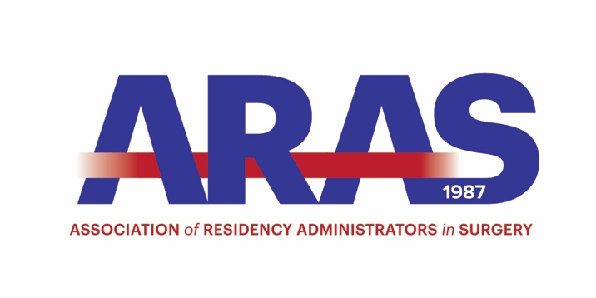

Association of Residency Administrators in Surgery

(ARAS)

Bylaws

2018

Revised 2017

Association of Residency Administrators in Surgery (ARAS)

Bylaws – 2017

ARTICLE 1 – Name, Office and Units

Section 1. Name

The name of the organization was changed April 2017 to the Association of Residency Administrators in Surgery (ARAS)

Section 2. Registered Office

Refer to the Association of Program Directors in Surgery (APDS) Bylaws

Section 3. Subordinate

Refer to the Association of Program Directors in Surgery (APDS) Bylaws

ARTICLE II – Mission and Purpose

Section 1. Mission

The ARAS is an organization established as an educational resource, a method for encouraging the exchange of ideas, and a support network for persons in the position of managing surgery residency programs.

The ARAS supports and promotes the certification process of Training Administrators of Graduate Medical Education (TAGME)

Section 2 Purpose

- To provide a forum for the exchange of information and for discussion on a wide-range of subjects related to post-graduate surgical education
- To maintain high standards of surgical residency training by improving graduate surgical education
- To provide advice, assistance, and support to program administrators on matters pertaining to surgical education and to accreditation
- To provide advice, assistance and support to other administrators through networking and mentoring
- To encourage research into all aspects of the education and training of surgeons and surgical subspecialties
- To represent the interests of residency administrators in the education and training of high quality surgeons to other organizations, individuals and governmental agencies or regulatory bodies
- To educate the members of ARAS and foster professional development and lifelong learning
- To provide an understanding of current accreditation standards

ARTICLE III – Members

Section 1 Member Eligibility

Full membership in the ARAS is limited to officially designated general surgery residency coordinators, administrators, and managers

Subspecialty administrators may become Associate members of the APDS. Please refer to the APDS Bylaws membership eligibility

Section 2 Member Requirements

The ARAS is supported by the Association of Program Directors in Surgery (APDS). Associate membership in the APDS is required for membership in the ARAS. Application for associate membership in the APDS includes submission of the administrator’s curriculum vitae and a letter of support from his/her Program Director.

All applications should be forwarded to:

APDS/ARAS
6400 Goldsboro Road
Suite 200
Bethesda, MD 20817

Applications are reviewed and voted on by the APDS Executive Committee at the fall planning meeting and the annual spring meeting. New members will receive notification upon approval of membership.

Section 3 Rights of Members

Being a member of ARAS affords you:

- Membership in a professional National Organization
- The right to participate in the annual ARAS meeting at a discounted registration rate
- The opportunity to present lectures at these meetings
- The right to participate on Ad Hoc committees organized by the ARAS Executive Committee
- The right to become an Executive Officer of ARAS
- The right to participate in any elections called by the ARAS President

Section 4 Meetings of Members

All meetings of the members shall be held annually in conjunction with the APDS annual meeting.
Meeting date and place will be determined by the APDS Board of Directors.

ARTICLE IV – Executive Committee

Section 1 Composition

The ARAS Executive Committee is composed of a maximum of nine (9) members. Two committee members are added each year and will serve a four-year term. The Immediate Past-President will serve one additional year as the ninth member.

Section 2 Terms

The Executive Officers are elected from the membership section and voted upon by the ARAS Executive Committee. ARAS Executive Officers must be General Surgery Residency Program coordinators, administrators or managers.

Officer roles are as follows:

- President – one year term
- President-Elect – one year term
- Executive Secretary – minimum of one two-year term and/or a maximum of four years
- Immediate Past-President – one year term
- Five additional Officers
*Refer to the ARAS Executive Committee Handbook for other committee roles and responsibilities

Section 3 Vacancies

Any unexpected vacancies on the Executive Committee may result in the re-appointment of past Executive Committee members to fill that role for the reminder of the year.

Section 4 Requirements

Membership on the ARAS Executive Committee requires the following:

- Membership of ARAS (refer to ARTICLE III)
- Attendance at a minimum of three APDS/ARAS meetings
- Written support, including financial support from the administrators’ surgery program director and chair
- The ability to attend the fall American College of Surgeons meeting, spring ARAS conference and any additional planning sessions called by the ARAS President

Section 5 Duties of ARAS Executive Committee

The ARAS Executive Committee is the liaison between the APDS and ARAS membership. The ARAS Executive Committee is responsible for the development and coordination of the curriculum for the Annual ARAS Conference.

*Refer to ARAS Executive Committee Handbook for committee roles and responsibilities

ARTICLE V – Committee

Section 1 Program Committee

A current member of the ARAS Executive Committee will represent ARAS on the APDS program committee.

A current member of the ARAS Executive Committee will represent ARAS on the SCORE Committee

A current member of the ARAS Executive Committee will represent ARAS on the ACS Committee

Section 2 AD HOC Committees

The ARAS President may, from time to time, appoint such Ad Hoc committees as deemed necessary to conduct the affairs of the ARAS. The structure, term and duties of such Ad Hoc committees shall be as determined by the ARAS President subject to the approval of the ARAS Executive Committee. The ARAS President will serve as an Ex-Officio member of all Ad Hoc Committees.

ARTICLE VI – Finances

Section 1 Fees and Charges

All meeting fees and charges are established by the APDS Board of Directors

Section 2 Responsibility for Expenses

The APDS shall provide meeting rooms and support services in support of the ARAS Executive Committee activities

ARTICLE VII – Professionalism

ARAS fully promotes and encourages professional behavior and conduct as it relates to residency program management, presentations at conferences and representation on any ARAS committee or activity

Section 1 ARAS Executive Committee

ARAS Executive Committee members are expected to fulfill all responsibilities as assigned
- In the event, that an ARAS Committee member is unable to fulfill his or her responsibilities, the Executive Committee will meet to discuss what action, if any will be taken
- ARAS Executive Committee members who are absent two consecutive meetings may be removed by action of the ARAS President

ARTICLE VIII – General Provisions

All ARAS materials, Logo, Handbooks, and other documents are for the explicit use of the ARAS and must
not be duplicated, except with the written permission of the ARAS Executive Committee

ARTICLE IX – Amendments

These Bylaws can be amended or appealed by the ARAS Executive Committee with approval from the majority of its membership at the ARAS Annual meeting or by virtual vote if changes need to be made sooner.

Submitted to APDS 10/2010
Effective 04/26/2011
Reviewed/No changes made/Submitted to APDS 10/2014
Approved APDS 10/2014
Approved APDS 10/2016

